|  |
| --- |
| **SPONSORSHIP AND GIFT AID DECLARATION FORM** |

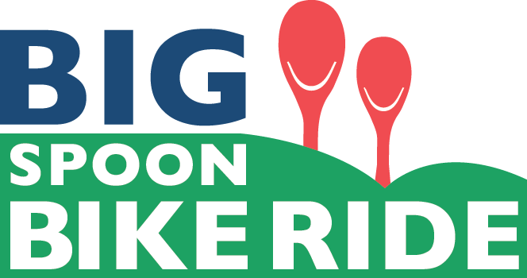

**My name is……………………………………………………….**

|  |
| --- |
| On June 18th 2023, I’m taking part in the Black Sheep Big Spoon Bike Ride to raise money for disadvantaged children in Yorkshire by supporting the Wooden Spoon charity. Please sponsor me. |

|  |  |  |  |  |  |
| --- | --- | --- | --- | --- | --- |
| **Name please PRINT** | **Home address** | **Postcode** | **Amount (£)** | **Gift aid? (please tick)** | **Date paid** |
|  |  |  |  |  |  |
|  |  |  |  |  |  |
|  |  |  |  |  |  |
|  |  |  |  |  |  |
|  |  |  |  |  |  |
| **If I have written my name on this sponsorship form and ticked the “Gift Aid” box, I want the Wooden Spoon charity to reclaim tax on my donation. I understand that I must pay an amount of income tax or capital gains tax at least equal to the tax reclaimed by the charity on the donation.**  **Wooden Spoon is a registered charity in England and Wales (326691) and in Scotland (SCO39247).**  **(Please turn over)** | | | | | |

|  |  |  |  |  |  |
| --- | --- | --- | --- | --- | --- |
| **Name please PRINT** | **Home address** | **Postcode** | **Amount (£)** | **Gift aid? (please tick)** | **Date paid** |
|  |  |  |  |  |  |
|  |  |  |  |  |  |
|  |  |  |  |  |  |
|  |  |  |  |  |  |
|  |  |  |  |  |  |
|  |  |  |  |  |  |
|  |  |  |  |  |  |
|  |  |  |  |  |  |
|  |  |  |  |  |  |
|  |  |  |  |  |  |
| **If I have written my name on this sponsorship form and ticked the “Gift Aid” box, I want the Wooden Spoon charity to reclaim tax on my donation. I understand that I must pay an amount of income tax or capital gains tax at least equal to the tax reclaimed by the charity on the donation.**  **Wooden Spoon is a registered charity in England and Wales (326691) and in Scotland (SCO39247).** | | | | | |

